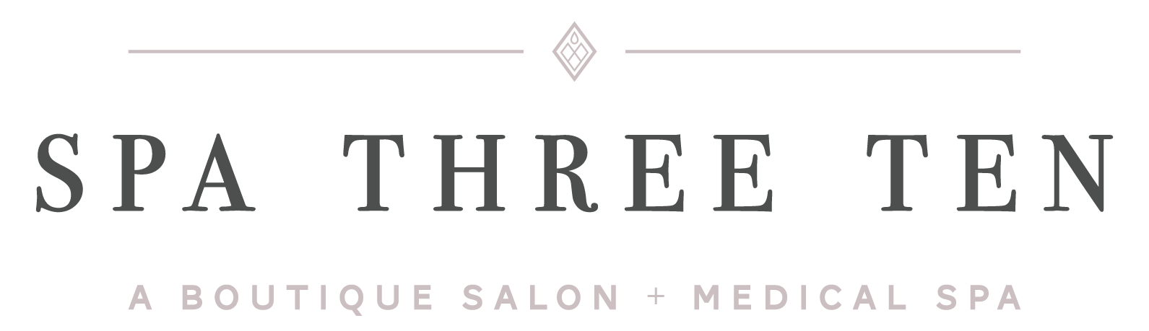

Informed Consent - Non Ablative Laser Facial
I understand that 4-6 treatments are required for the non-ablative laser facial to be most effective. I understand that it is important to follow the recommended maintenance schedule for future treatments to keep the best possible results. I also realize that each individual’s treatment response may be different; therefore, the number of treatments may vary to achieve desired results.
Initials ____
I understand that erythema is a common immediate reaction from the non-ablative laser facial treatment process. This typically resolves within 2 hours, but can last longer. There is a possibility of rare side effects such as a blister or swelling that may occur. I may also feel a warming sensation of the skin during the treatment. This is a temporary condition and I understand that each person’s discomfort level may vary.
Initials ____
I understand that sun exposure, tanning beds, sunless tanning lotion and tanning creams can cause discoloration or a reaction prior to or during the course of laser treatments. A broad spectrum (UVA/UVB) sunscreen SPF 30 or greater should be applied to the area(s) to be treated whenever exposed to the sun.
Initials ____
I also understand that once I’ve started my treatment program there are no refunds.
Initials ____
I consent to photographs and digital images being taken to evaluate treatment effectiveness, for medical education, training, professional publications or sales purposes. No photographs or digital images revealing my identity will be used without my written consent. If my identity is not revealed, these photographs and digital images may be used, shared, and displayed publicly without my permission.
______ (Please Initial)

ACKNOWLEDGMENT:
My questions regarding the procedure have been answered satisfactorily. I understand the procedure and accept the risks.
I certify that I have read this entire consent and that I understand and agree to the information provided in this form. I certify that I am competent adult of at least 18 years of age, or that, if I am a minor under the age of 18, I understand that the consent of my parent/guardian having legal custody will also be required before treatment. I agree and adhere to all safety precautions and regulations during the skin treatment. I further agree to follow all post-treatment care instructions as I am directed. I hereby release Spa Three Ten and Jessica VanTuyle, M.D. from all liabilities associated with the above indicated procedure.

Patient’s Signature:_______________________________________Date:__________________
Practitioner Signature:____________________________________Date: ____________

